# 

**American International University Bangladesh**

**DataBase Project**

**“Apartment Management System”**

Submitted to

**Juena Ahmed Noshin**

[**juena@aiub.edu**](mailto:juena@aiub.edu)

Submitted by

|  |  |  |
| --- | --- | --- |
| NAME | ID | SECTION |
| 1.Nusrat, Jannatul | **19-40885-2** | **H** |
| 2.Sajib, Nahid Hasan | **19-40866-2** | **H** |
| 3.Sezan,Tanjin Rashid | **19-40887-2** | **H** |
| 4.Linkon, Ankon Sarkar | **19-40895-2** | **H** |
| 5.Rabby, H.M Jayed Chowdhury | **19-40893-2** | **H** |
| 6.Badhan, Walid Bin Wahid | **19-40845-2** | **H** |

**Course: Introduction to Database**

# **“Apartment Management System”**

# **CONTENTS:**

|  |  |
| --- | --- |
| Introduction | 03 |
| Scenario Description | 04 |
| ER Diagram | 05 |
| Normalization | 06-11 |
| Schema Diagram | 12 |
| Table Creation | 13-21 |
| Data Insertion | 22-29 |
| Query Writing | 30-35 |
| Relational Algebra | 36 |
| Conclusion | 37-38 |

# **Introduction:**

For our project, we have decided to make a model of “**Apartment Management System**”. The AMS requires a tool to be built for a local building management company wishing to automate many of the interactions between apartment members and apartment manager. The system needs to keep the record of every contact detail of the apartment manager and the apartment users. In addition to just handling rent money exchange, this system stores the details of apartment buildings, apartments, apartment facilities and so on.

The project proved to be a large undertaking as we spent a significant amount of time delving into the details of what the management system, an apartment building requires and all of the rent laws & other facilities.

We had team members who worked on storing contact details of both apartment manager & apartment member, apartment details as well as the building details, rent interactions. The following design document reflects all of those features and more.

For the group members, this project proved to be quite the learning experience. We hope the following can accurately portray a sample of what such a software suite would require and how it could be coded to become a reality.

The overall goals of the system are to keep track of manager & members record, user management requests, document and rent collection, apartment facilities.

# **Scenario Description:**

In an “**Apartment Management System”** apartments are managed by a manager. The system stores manager id, name, phone and salary. A member can rent one or more than one apartment in the same building. Every member is identified by a user name. The system also stores member id, phone, password and email. In an apartment management system, apartment building has a unique id, building’s full name & also building’s short name. Apartment building has apartments. In an **AMS** details ofapartments’ such as id, rental price, bedroom count and bathroom count are also stored. The system also stores a list of apartment facilities (gas, electricity, water, security) with an unique id of apartment facilities. In addition to all these, this system also keeps a record of rent details (rent id, due date, rent fee, apartment facilities fee, late fee, payment date, payment amount) paid by the members.

**ER Diagram:**

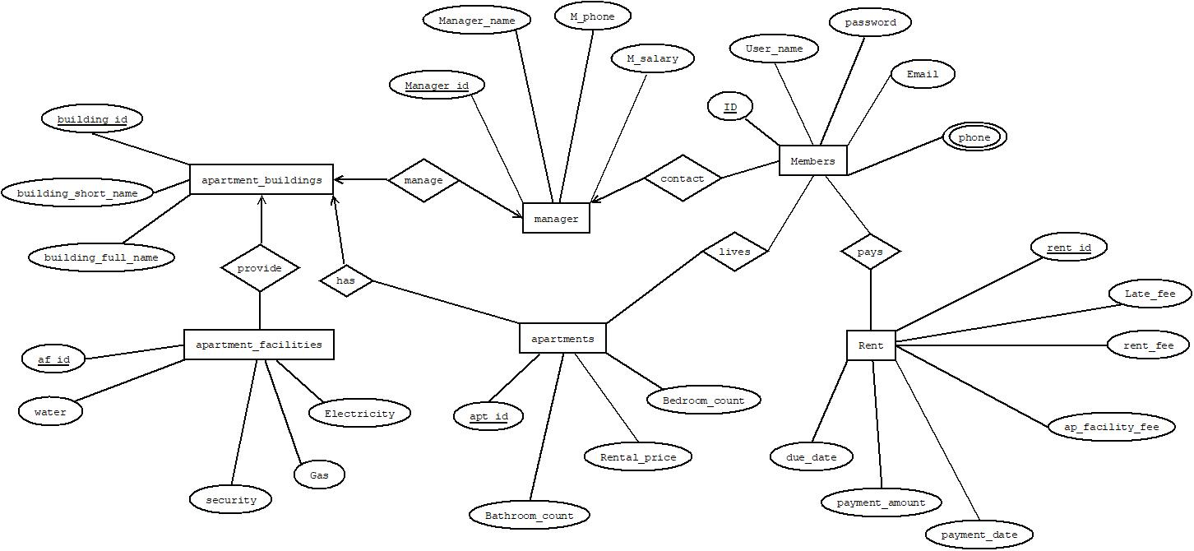

**Normalization:**

**Provide**

**UNF**

Provide(building_id,building_short_name,building_full_name,af_id,water,security,gas,electricity)

**1NF**

1. There is no multi valued attribute.Relation already in1NF. building_id,building_short_name,building_full_name,af_id,water,security,gas,el ectricity.

**2NF**

1. building_id,building_short_name,building_full_name
2. af_id,water,security,gas,electricity

**3NF**

There is no transitive dependency

1. building_id,building_short_name,building_full_name
2. af_id,water,security,gas,electricity,building_id.

**Has**

**UNF**

Has(building_id,building_short_name,building_full_name,apt_id,bathroom_count,rental_price,bedroom_count)

**1NF**

There is no multi valued attribute.Relation already in 1NF.

1. building_id,building_short_name,building_full_name,apt_id,bathroom_count,rental_price,bedroom_count.

**2NF**

1. building_id,building_short_name,building_full_name.
2. apt_id,bathroom_count,rental_price,bedroom_count.

**3NF**

There is no transitive dependency.

1. building_id,building_short_name,building_full_name.
2. apt_id,bathroom_count,rental_price,bedroom_count,building_id.

**Manage**

**UNF**

Manage(building_id,building_short_name,building_full_name,manager_id,manager_name,M_phone,Msalary)

**1NF**

There is no multi valued attribute.Relation already in 1NF.

1. building_id,building_short_name,building_full_name,manager_id,manager_name,M_phone,M_salary.

**2NF**

1. building_id,building_short_name,building_full_name.
2. manager_id,manager_name,M_phone,M_salary.

**3NF**

There is no transitive dependency

1. building_id,building_short_name,building_full_name.
2. manager_id,manager_name,M_phone,M_salary,building_id.

**Contact**

**UNF**

Contact(manager_id,manager_name,M_phone,M_salary,ID,user_name,password,email,phone)

**1NF**

Phone is a multi valued attribute.

1. manager_id,manager_name,M_phone,M_salary,ID,user_name,password,email,phone.

**2NF**

1. manager_id,manager_name,M_phone,M_salary.
2. ID,user_name,password,email,phone.

**3NF**

There is no transitive dependency.

1. manager_id,manager_name,M_phone,M_salary.
2. ID,user_name,password,email,phone,manager_id.

**Lives**

**UNF**

Lives(apt_id,bathroom_count,rental_price,bedroom_count, ID,user_name,password,email,phone)

**1NF**

Phone is a multi valued attribute.

1. apt_id,bathroom_count,rental_price,bedroom_count, ID,user_name,password,email,phone.

**2NF**

1. apt_id,bathroom_count,rental_price,bedroom_count.
2. ID,user_name,password,email,phone.

**3NF**

There is no transitive dependency.

1. apt_id,bathroom_count,rental_price,bedroom_count.
2. ID,user_name,password,email,phone.
3. apt_id ,ID.

**Pays**

**UNF**

Pays(ID,user_name,password,email,phone,rent_id,late_fee,rent_fee,ap_facility_fee,payment_date,payment_amount,due_date)

**1NF**

Phone is a multi valued attribute.

1. ID,user_name,password,email,phone,rent_id,late_fee,rent_fee,ap_facility_fee,payment_date,payment_amount,due_date.

**2NF**

1. ID,user_name,password,email,phone.
2. rent_id,late_fee,rent_fee,ap_facility_fee,payment_date,

payment_amount,due_date.

**3NF**

There is no transitive dependency.

1. ID,user_name,password,email,phone.
2. rent_id,late_fee,rent_fee,ap_facility_fee,payment_date,

payment_amount,due_date.

1. ID,rent_id.

**Temporary Tables:**

1. building_id,building_short_name,building_full_name.
2. af_id,water,security,gas,electricity,**building_id**.
3. **~~building_id~~**~~,building_short_name,building_full_name.~~
4. apt_id,bathroom_count,rental_price,bedroom_count,**building_id**.
5. **~~building_id~~**~~,building_short_name,building_full_name.~~
6. manager_id,manager_name,M_phone,M_salary,**building_id**.
7. **~~manager_id~~**~~,manager_name,M_phone,M_salary.~~
8. ID,user_name,password,email,phone,**manager_id**.
9. ~~Apt_id,bathroom_count,rental_price,bedroom_count.~~
10. ~~ID,user_name,password,email,phone.~~
11. **apt_id ,ID**.
12. ~~ID,user_name,password,email,phone.~~
13. rent_id,late_fee,rent_fee,ap_facility_fee,payment_date,

payment_amount,due_date.

1. **ID,rent_id.**

**Final Tables:**

1. **building_id**,building_short_name,building_full_name.
2. af_id,water,security,gas,electricity,**building_id**.
3. apt_id,bathroom_count,rental_price,bedroom_count,**building_id**.
4. manager_id,manager_name,M_phone,M_salary,**building_id**.
5. ID,user_name,password,email,phone,**manager_id**.
6. **apt_id** ,**ID**.
7. rent_id,late_fee,rent_fee,ap_facility_fee,payment_date,

payment_amount,due_date.

1. **ID**,**rent_id**.

**Schema Diagram:**

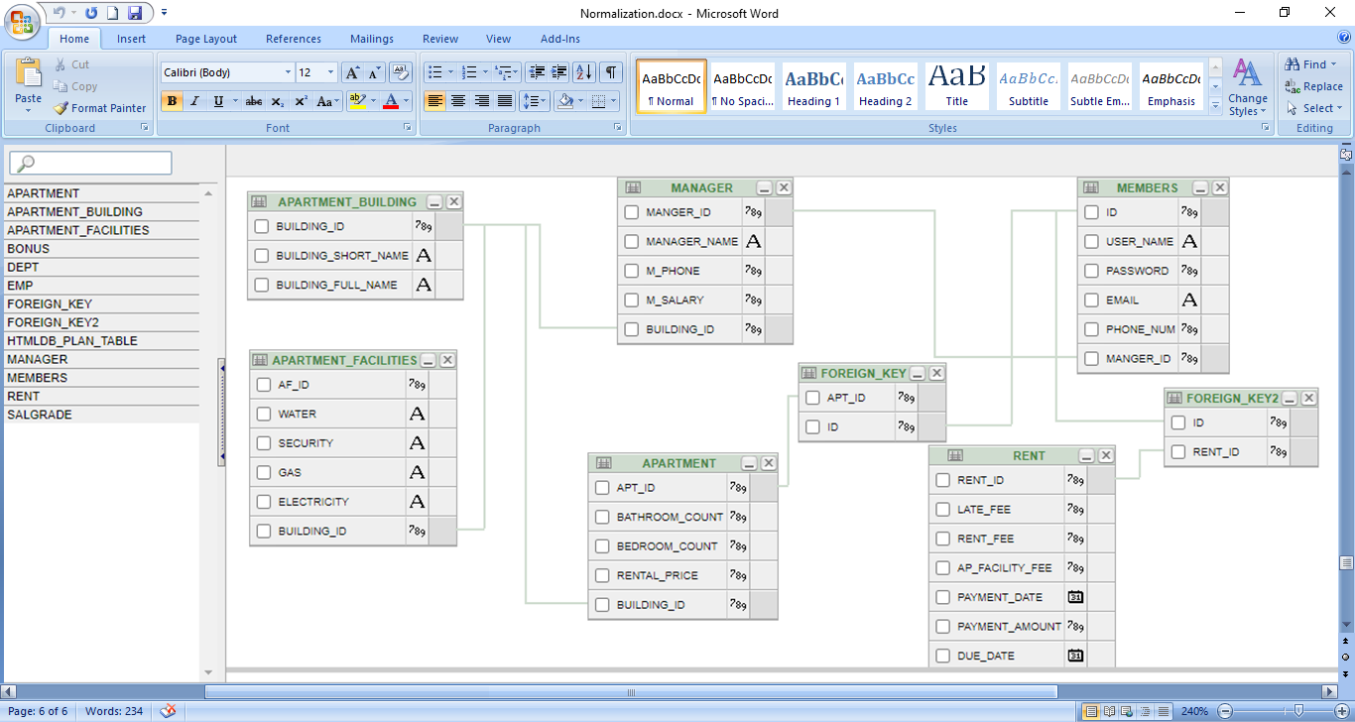

**Table Creation:**

* **After normalization tables are (including constraints):**

1. APARTMENT_BUILDING ( BUILDING_ID, BUILDING_SHORT_NAME, BUILDING_FULL_NAME)

2.APARTMENT(APT_ID,BATHROOM_COUNT,BEDROOM_COUNT,RENTAL_PRICE,**BUILDING_ID**)

3. APARTMENT_FACILITIES (AF_ID, WATER,SECURITY, GAS, ELECTRICITY, **BUILDING_ID**)

4. MANAGER (MANAGER_ID, MANAGER_NAME, M_PHONE, M_SALARY, **BUILDING_ID**)

5. MEMBERS(ID, USER_NAME, PASSWORD, EMAIL, PHONE_NUM, **MANAGER_ID)**

6. FOREIGN_KEY (**APT_ID**, **ID** )

7. RENT (RENT_ID, LATE_FEE, RENT_FEE, AP_FACILITY_FEE, PAYMENT_DATE, PAYMENT_AMOUNT, DUE_DATE)

8. FOREIGN_KEY2 (**ID, RENT_ID** )

**Using DESC command:**

Table APARTMENT_BUILDING:

CREATE TABLE APARTMENT_BUILDING(BUILDING_ID NUMBER(20)PRIMARY KEY,BUILDING_SHORT_NAME VARCHAR2(20),BUILDING_FULL_NAME VARCHAR2(20));

CREATE SEQUENCE BUILDING_BUILDING_ID INCREMENT BY 1 START WITH 105 MAXVALUE 500 NOCACHE NOCYCLE;

desc APARTMENT_BUILDING;

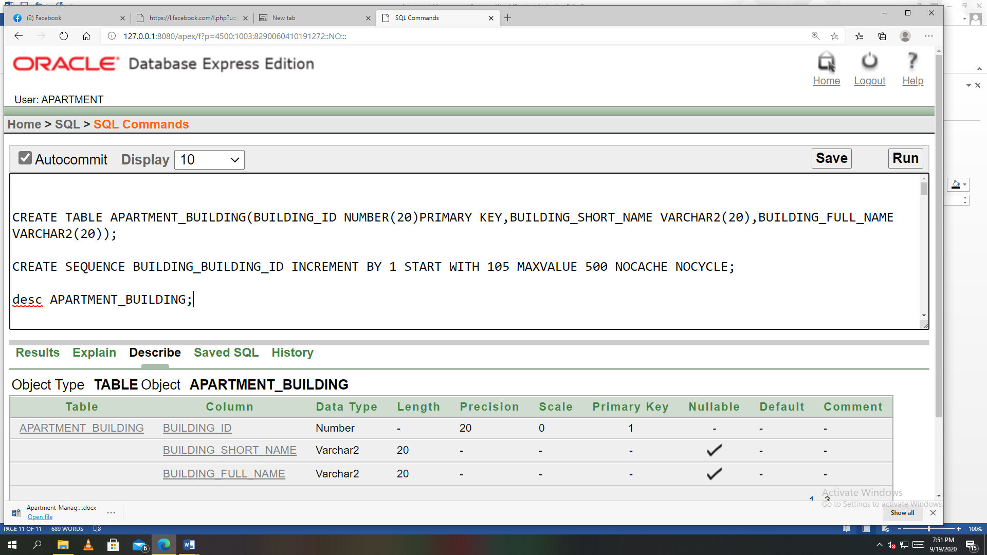

Table APARTMENT:

CREATE TABLE APARTMENT(APT_ID NUMBER(20)PRIMARY KEY,BATHROOM_COUNT NUMBER(20),BEDROOM_COUNT NUMBER(20),RENTAL_PRICE NUMBER(30),BUILDING_ID NUMBER(20));

# ALTER TABLE APARTMENT ADD CONSTRAINT FK3 FOREIGN KEY(BUILDING_ID) REFERENCES APARTMENT_BUILDING(BUILDING_ID);

# CREATE SEQUENCE APARTMENT_APT_ID INCREMENT BY 1 START WITH 1005 MAXVALUE 5000 NOCACHE NOCYCLE;

# desc APARTMENT;

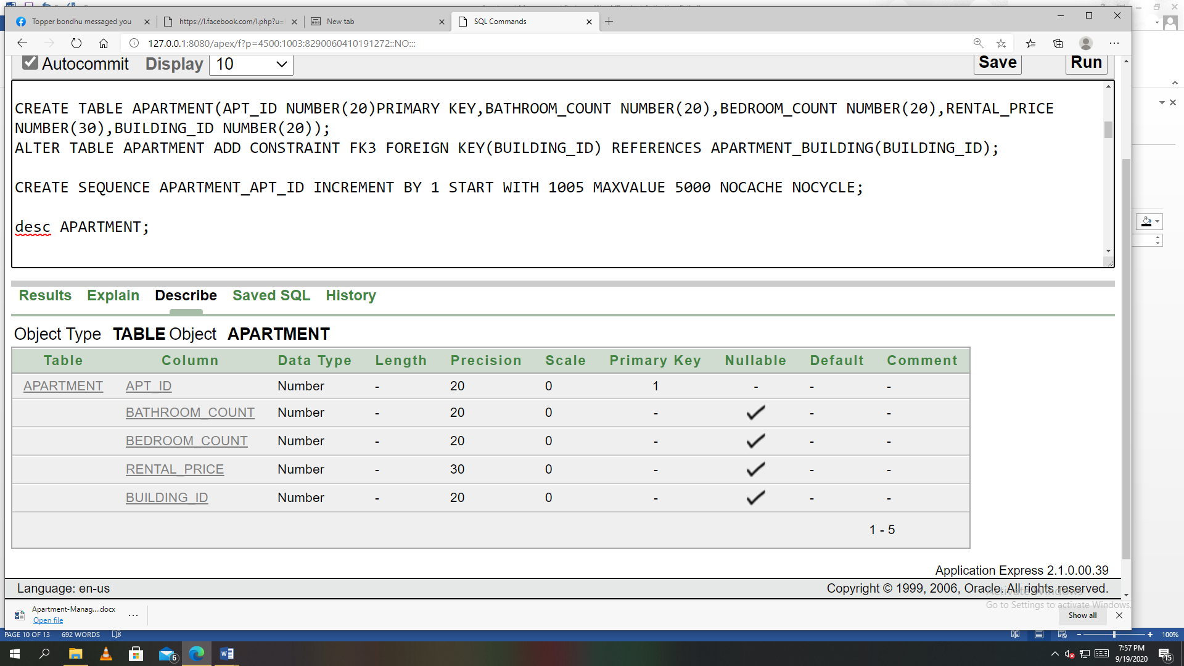

Table APARTMENT_FACILITIES:

CREATE TABLE APARTMENT_FACILITIES(AF_ID NUMBER(20)PRIMARY KEY,WATER VARCHAR2(20),SECURITY VARCHAR2(20),GAS VARCHAR2(20),ELECTRICITY VARCHAR2(20),BUILDING_ID NUMBER(20));

ALTER TABLE APARTMENT_FACILITIES ADD CONSTRAINT FK4 FOREIGN KEY(BUILDING_ID) REFERENCES APARTMENT_BUILDING(BUILDING_ID);

CREATE SEQUENCE APARTMENT_FACILITIES_AF_ID INCREMENT BY 1 START WITH 5 MAXVALUE 100 NOCACHE NOCYCLE;

desc APARTMENT_FACILITIES;

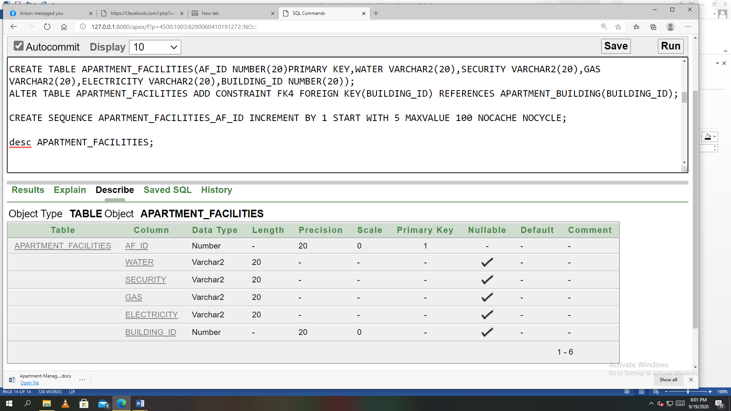

Table MANAGER:

CREATE TABLE MANAGER (MANAGER_ID NUMBER(20)PRIMARY KEY,MANAGER_NAME VARCHAR2(30),M_PHONE NUMBER(20),M_SALARY NUMBER(20),BUILDING_ID NUMBER(20));

ALTER TABLE MANAGER ADD CONSTRAINT FK5 FOREIGN KEY(BUILDING_ID) REFERENCES APARTMENT_BUILDING(BUILDING_ID);

CREATE SEQUENCE MANAGER_MANAGER_ID INCREMENT BY 1 START WITH 115 MAXVALUE 500 NOCACHE NOCYCLE;

desc MANAGER;

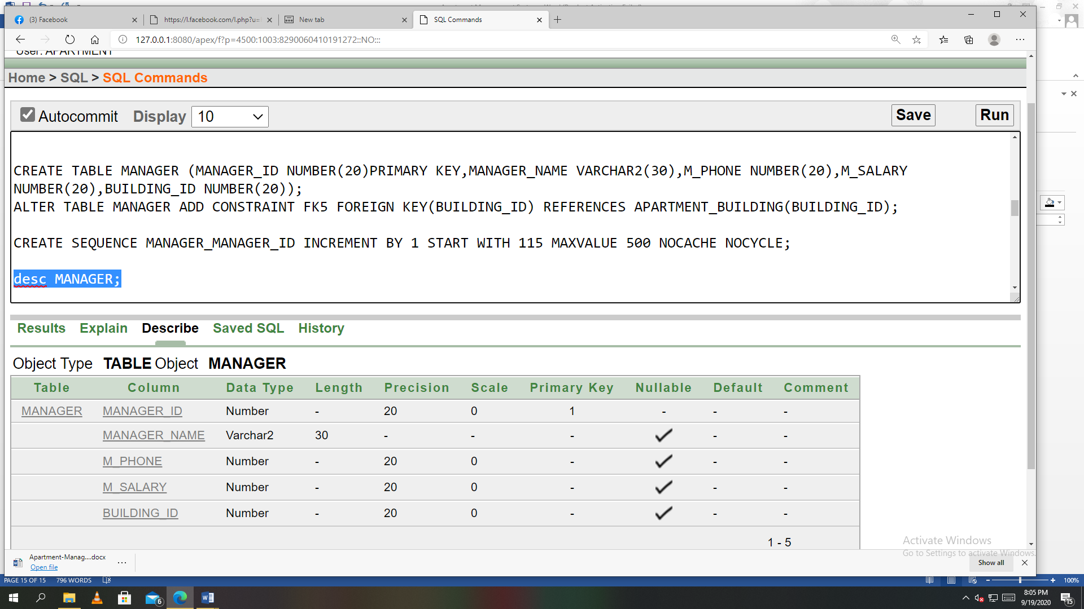

Table MEMBERS:

CREATE TABLE MEMBERS(ID NUMBER(20)PRIMARY KEY,USER_NAME VARCHAR2(20),PASSWORD NUMBER(20),EMAIL VARCHAR2(20),PHONE_NUM NUMBER(20),MANAGER_ID NUMBER(20));

ALTER TABLE MEMBERS ADD CONSTRAINT FK6 FOREIGN KEY(MANAGER_ID) REFERENCES MANAGER(MANAGER_ID);

CREATE SEQUENCE MEMBERS_ID INCREMENT BY 1 START WITH 4005 MAXVALUE 5000 NOCACHE NOCYCLE;

desc MEMBERS;

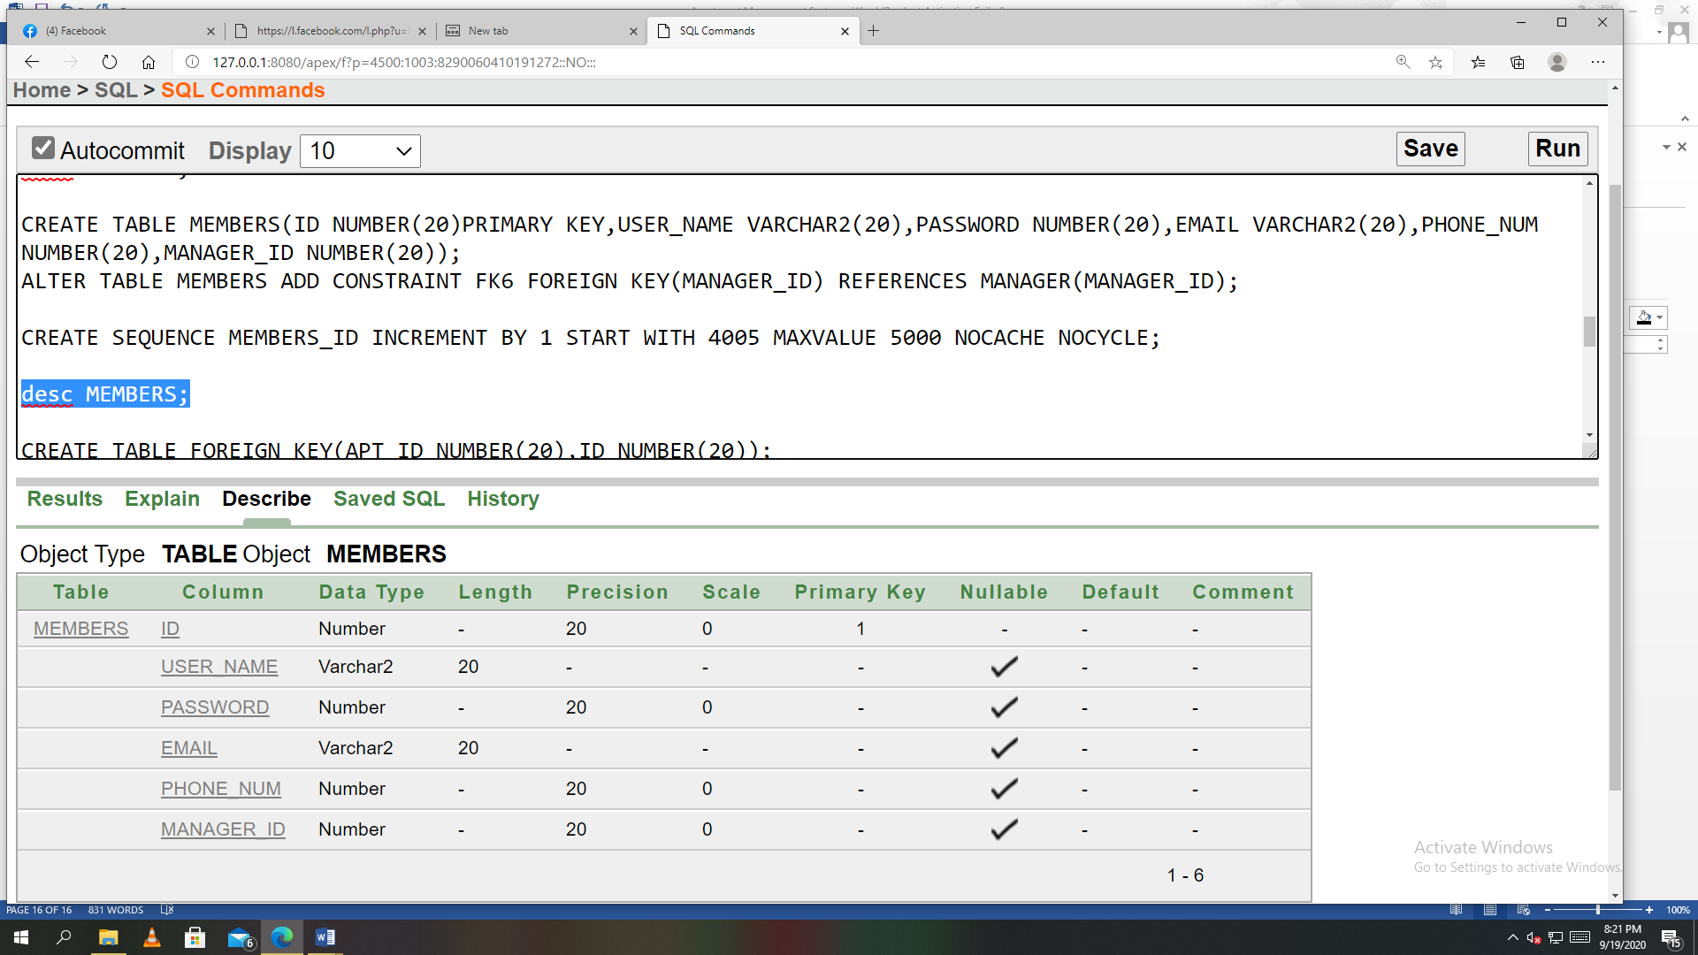

Table FOREIGN_KEY:

CREATE TABLE FOREIGN_KEY(APT_ID NUMBER(20),ID NUMBER(20));

ALTER TABLE FOREIGN_KEY ADD CONSTRAINT FK7 FOREIGN KEY(APT_ID) REFERENCES APARTMENT(APT_ID);

ALTER TABLE FOREIGN_KEY ADD CONSTRAINT FK8 FOREIGN KEY(ID) REFERENCES MEMBERS(ID);

DESC FOREIGN_KEY;

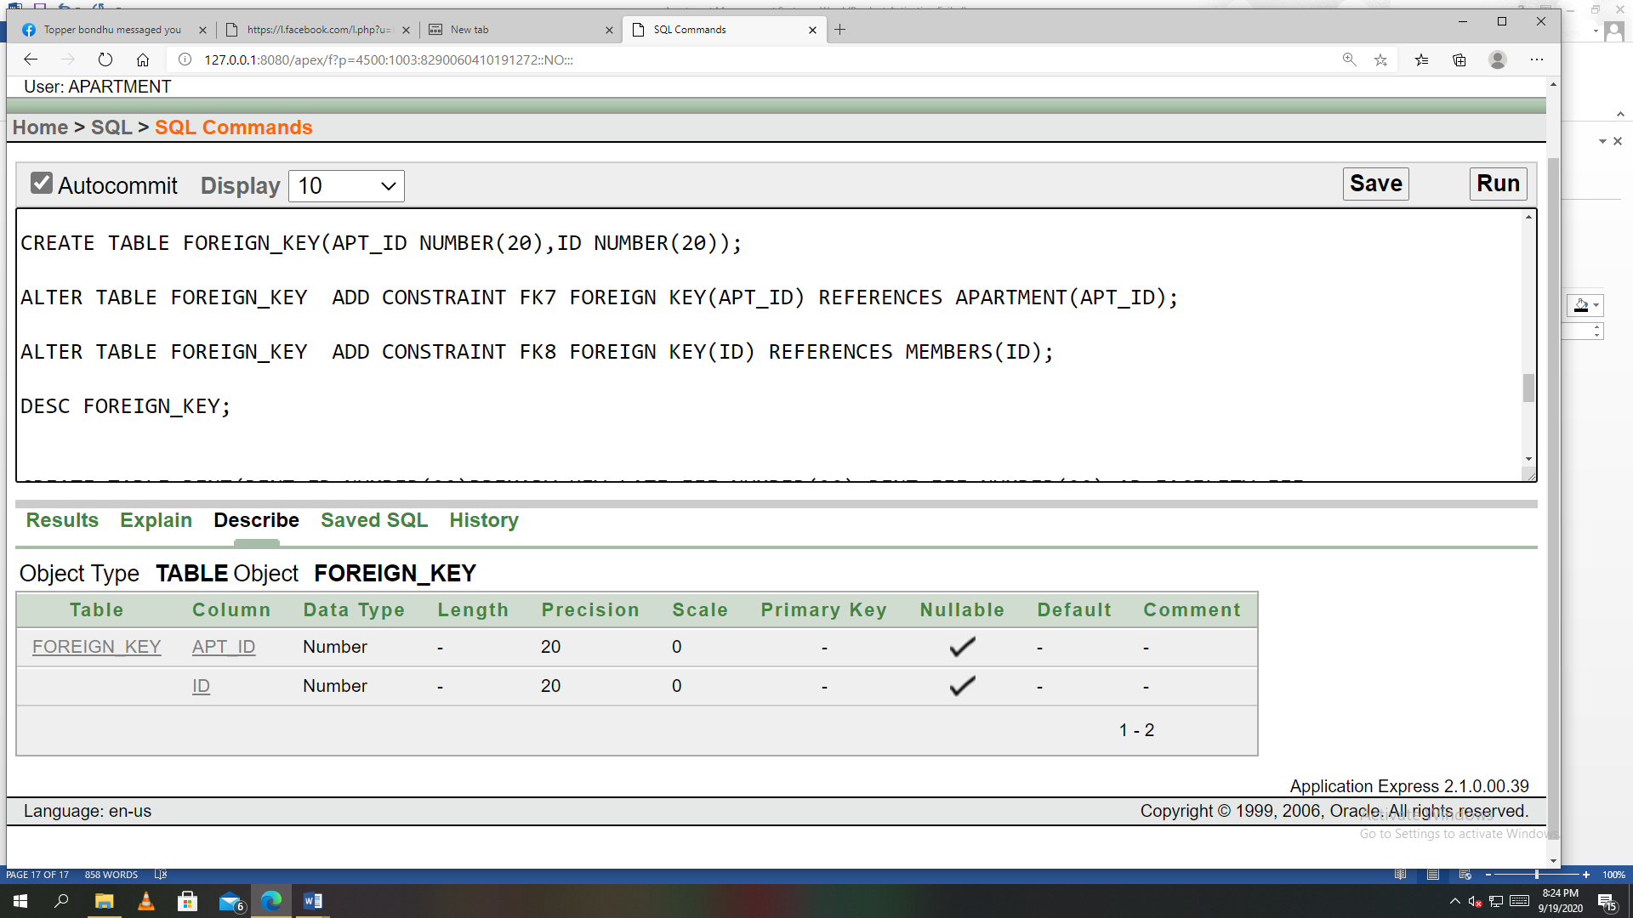

Table RENT:

CREATE TABLE RENT(RENT_ID NUMBER(20)PRIMARY KEY,LATE_FEE NUMBER(20),RENT_FEE NUMBER(20),AP_FACILITY_FEE NUMBER(20),PAYMENT_DATE DATE,PAYMENT_AMOUNT NUMBER(20),DUE_DATE DATE);

CREATE SEQUENCE RENT_RENT_ID INCREMENT BY 1 START WITH 5005 MAXVALUE 6000 NOCACHE NOCYCLE;

DESC RENT;

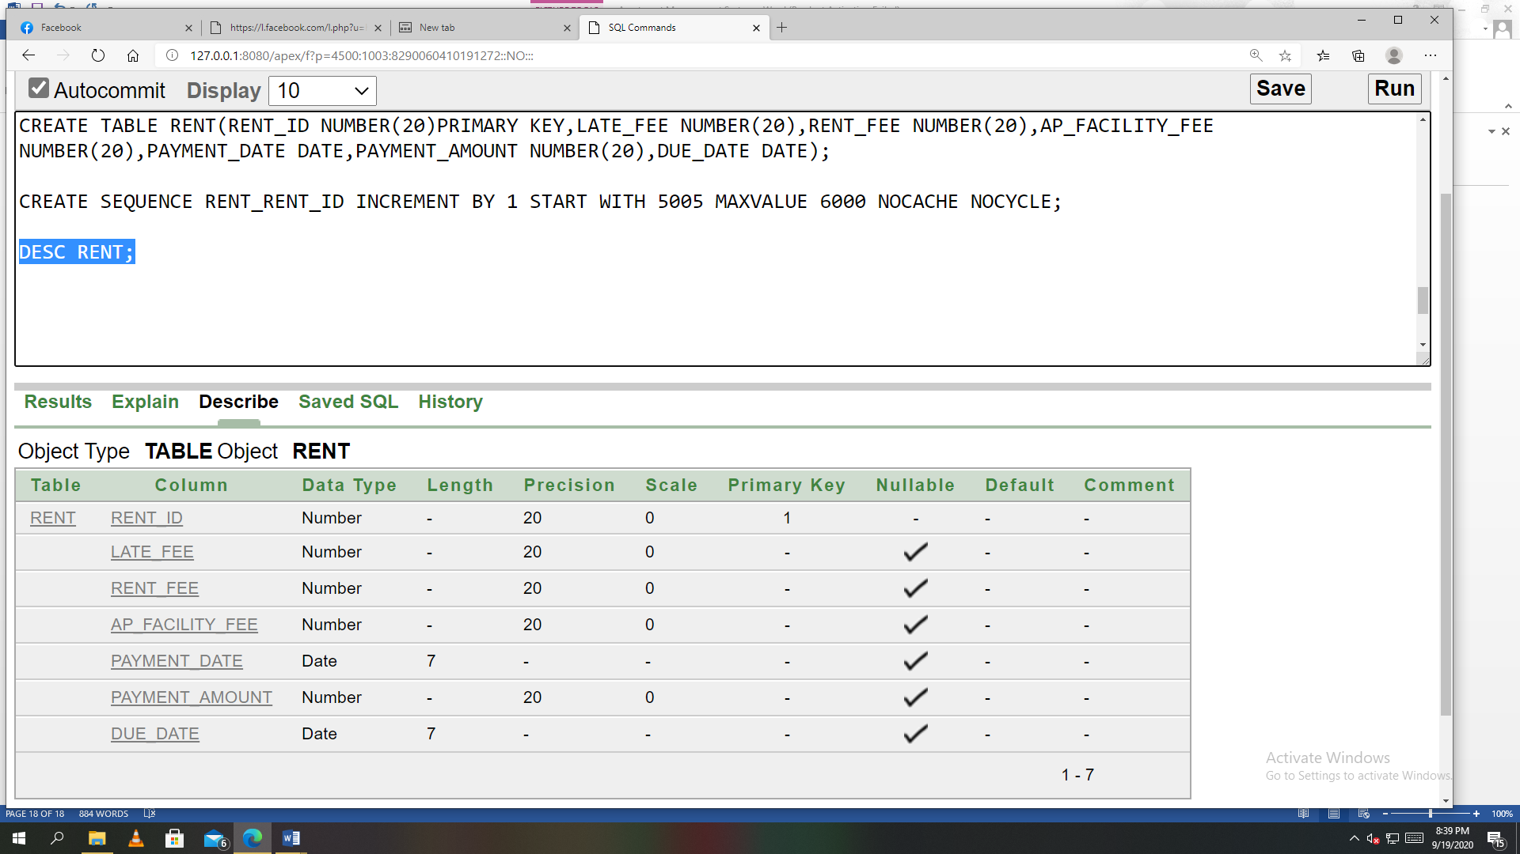

Table FOREIGN_KEY2:

CREATE TABLE FOREIGN_KEY2(ID NUMBER(20),RENT_ID NUMBER(20));

ALTER TABLE FOREIGN_KEY2 ADD CONSTRAINT FK9 FOREIGN KEY(ID) REFERENCES MEMBERS(ID);

ALTER TABLE FOREIGN_KEY2 ADD CONSTRAINT FK10 FOREIGN KEY(RENT_ID) REFERENCES RENT(RENT_ID);

DESC FOREIGN_KEY2;

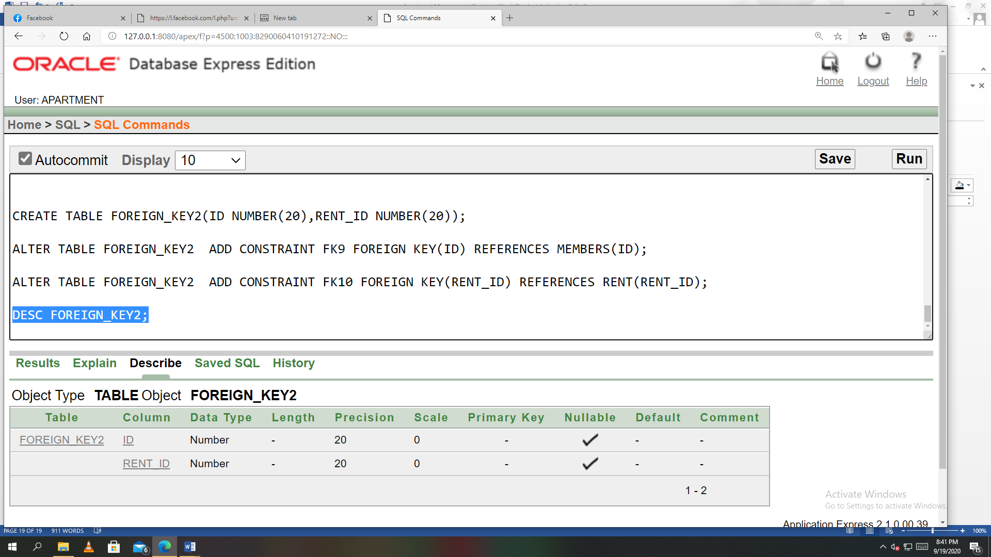

**Data Insertion:**

Table APARTMENT_BUILDING:

CREATE TABLE APARTMENT_BUILDING(BUILDING_ID NUMBER(20)PRIMARY KEY,BUILDING_SHORT_NAME VARCHAR2(20),BUILDING_FULL_NAME VARCHAR2(20));

INSERT INTO APARTMENT_BUILDING VALUES (101,'CCH','CITY CENTER,DHAKA');

INSERT INTO APARTMENT_BUILDING VALUES (102,'HD','HILTON DHAKA');

INSERT INTO APARTMENT_BUILDING VALUES (103,'NTG','NAVANA TOWER GULSHAN');

INSERT INTO APARTMENT_BUILDING VALUES (104,'ACI','AZIZ COURT IMPERIAL');

INSERT INTO APARTMENT_BUILDING VALUES (105,'AV','ANKON VILLA');

CREATE SEQUENCE BUILDING_BUILDING_ID INCREMENT BY 1 START WITH 105 MAXVALUE 500 NOCACHE NOCYCLE;

SELECT * FROM APARTMENT_BUILDING;

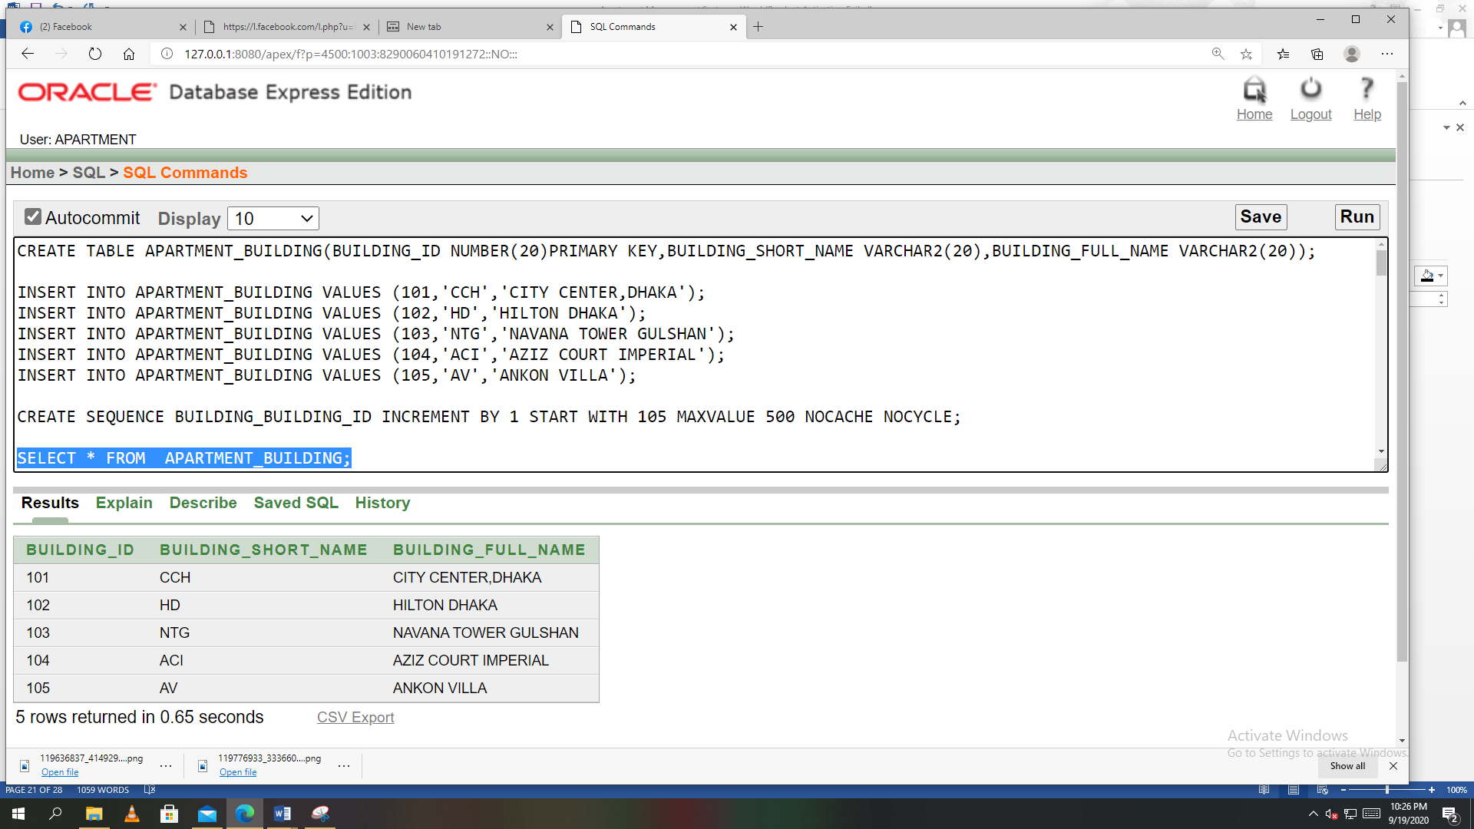

Table APARTMENT:

CREATE TABLE APARTMENT(APT_ID NUMBER(20)PRIMARY KEY,BATHROOM_COUNT NUMBER(20),BEDROOM_COUNT NUMBER(20),RENTAL_PRICE NUMBER(30),BUILDING_ID NUMBER(20));

ALTER TABLE APARTMENT ADD CONSTRAINT FK3 FOREIGN KEY(BUILDING_ID) REFERENCES APARTMENT_BUILDING(BUILDING_ID);

INSERT INTO APARTMENT VALUES (1001,3,4,40000,101);

INSERT INTO APARTMENT VALUES (1002,4,5,50000,102);

INSERT INTO APARTMENT VALUES (1003,2,3,35000,103);

INSERT INTO APARTMENT VALUES (1004,3,3,38000,104);

INSERT INTO APARTMENT VALUES (1005,4,6,55000,105);

CREATE SEQUENCE APARTMENT_APT_ID INCREMENT BY 1 START WITH 1005 MAXVALUE 5000 NOCACHE NOCYCLE;

SELECT * FROM APARTMENT;

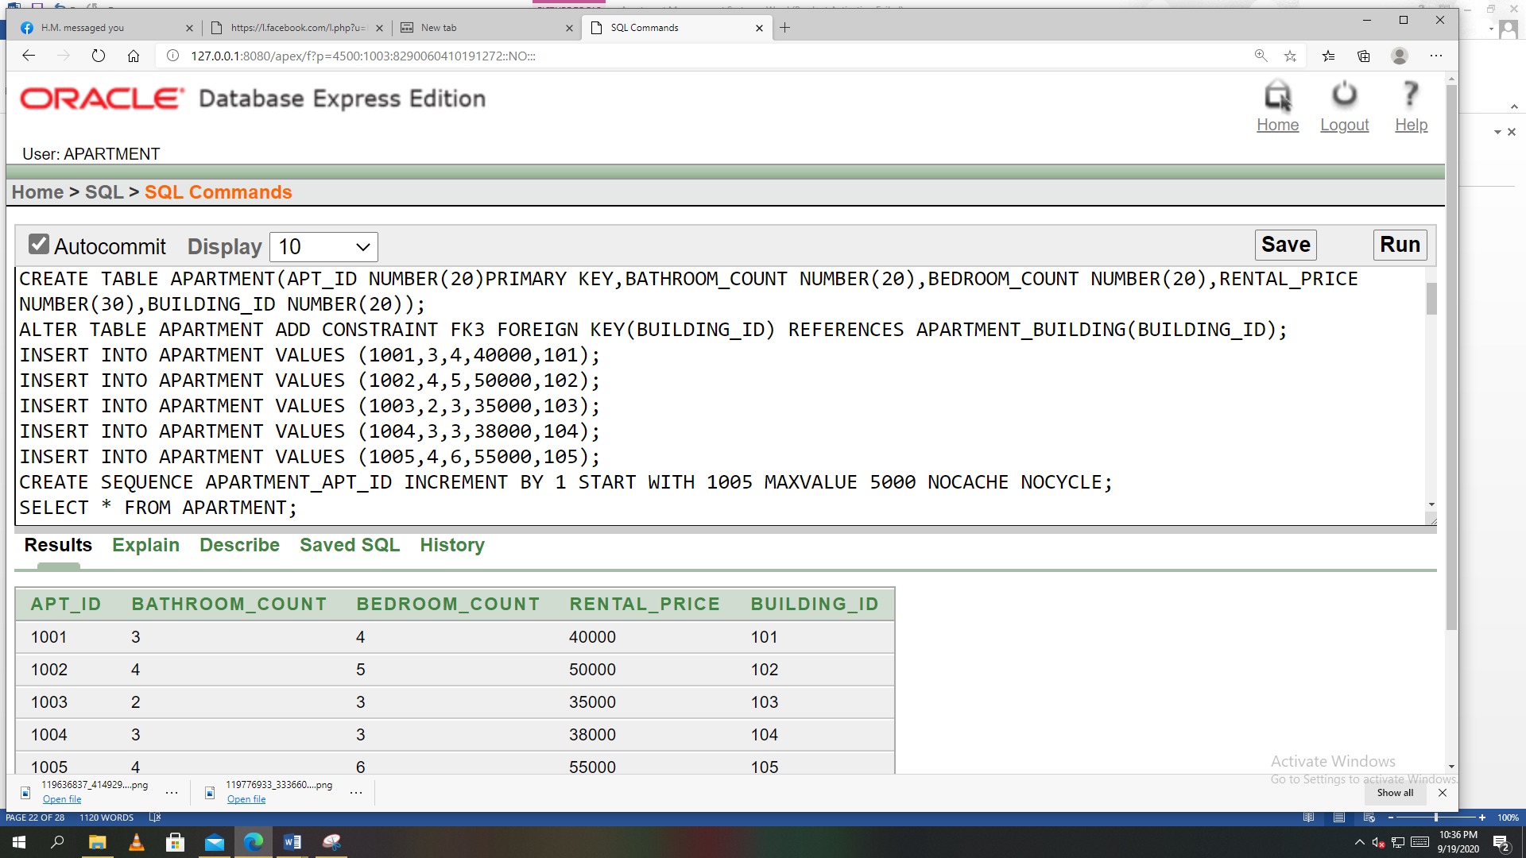

Table APARTMENT_FACILITIES:

CREATE TABLE APARTMENT_FACILITIES(AF_ID NUMBER(20)PRIMARY KEY,WATER VARCHAR2(20),SECURITY VARCHAR2(20),GAS VARCHAR2(20),ELECTRICITY VARCHAR2(20),BUILDING_ID NUMBER(20));

ALTER TABLE APARTMENT_FACILITIES ADD CONSTRAINT FK4 FOREIGN KEY(BUILDING_ID) REFERENCES APARTMENT_BUILDING(BUILDING_ID);

INSERT INTO APARTMENT_FACILITIES VALUES (01,'AVAILABLE','AVAILABLE','AVAILABLE','AVAILABLE',101);

INSERT INTO APARTMENT_FACILITIES VALUES (02,'AVAILABLE','AVAILABLE','AVAILABLE','AVAILABLE',102);

INSERT INTO APARTMENT_FACILITIES VALUES (03,'AVAILABLE','AVAILABLE',' NOT AVAILABLE','AVAILABLE',103);

INSERT INTO APARTMENT_FACILITIES VALUES (04,'AVAILABLE','AVAILABLE','AVAILABLE','AVAILABLE',104);

INSERT INTO APARTMENT_FACILITIES VALUES (05,'AVAILABLE','AVAILABLE','AVAILABLE','AVAILABLE',105);

CREATE SEQUENCE APARTMENT_FACILITIES_AF_ID INCREMENT BY 1 START WITH 5 MAXVALUE 100 NOCACHE NOCYCLE;

SELECT * FROM APARTMENT_FACILITIES;

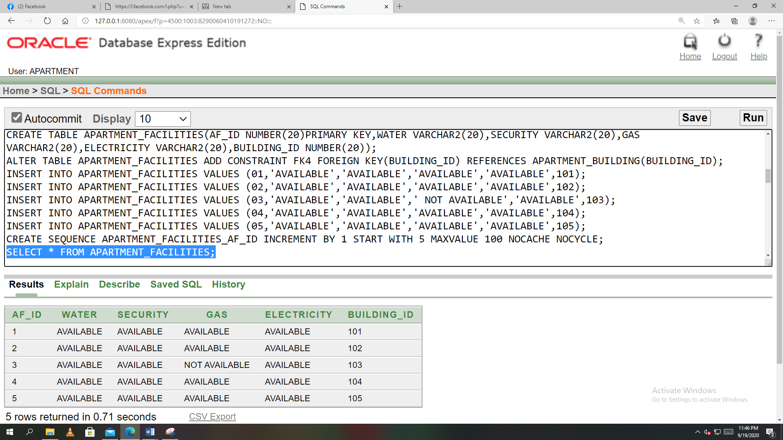

Table MANAGER:

CREATE TABLE MANAGER (MANGER_ID NUMBER(20)PRIMARY KEY,MANAGER_NAME VARCHAR2(30),M_PHONE NUMBER(20),M_SALARY NUMBER(20),BUILDING_ID NUMBER(20));

ALTER TABLE MANAGER ADD CONSTRAINT FK5 FOREIGN KEY(BUILDING_ID) REFERENCES APARTMENT_BUILDING(BUILDING_ID);

INSERT INTO MANAGER VALUES (111,'MD.RAHIM',01819809803,30000,101);

INSERT INTO MANAGER VALUES (112,'MD.KARIM',01997239740,35000,102);

INSERT INTO MANAGER VALUES (113,'MD.JASHIM',01831967980,20000,103);

INSERT INTO MANAGER VALUES (114,'MD.NILOY',01819834803,25000,104);

INSERT INTO MANAGER VALUES (115,'MD.RAFI',01991957687,15000,105);

CREATE SEQUENCE MANAGER_MANAGER_ID INCREMENT BY 1 START WITH 115 MAXVALUE 500 NOCACHE NOCYCLE;

SELECT * FROM MANAGER;

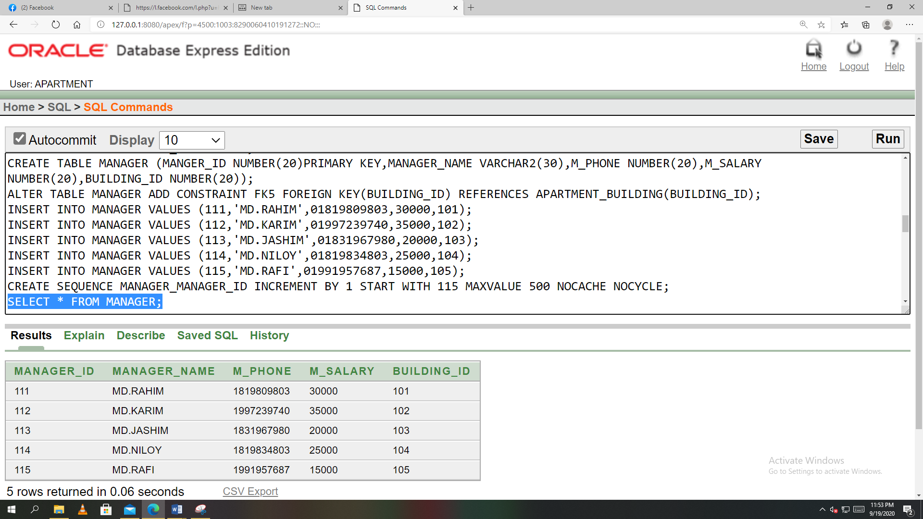

Table MEMBER:

CREATE TABLE MEMBERS(ID NUMBER(20)PRIMARY KEY,USER_NAME VARCHAR2(20),PASSWORD NUMBER(20),EMAIL VARCHAR2(20),PHONE_NUM NUMBER(20),MANGER_ID NUMBER(20));

ALTER TABLE MEMBERS ADD CONSTRAINT FK6 FOREIGN KEY(MANGER_ID) REFERENCES MANAGER(MANGER_ID);

INSERT INTO MEMBERS VALUES(4001,'MD.ANKON',9876,'ankon@gmail.com',01987654321,111);

INSERT INTO MEMBERS VALUES(4002,'MD.NAHID',7834,'nahid@gmail.com',01812345678,112);

INSERT INTO MEMBERS VALUES(4003,'Ms.TURNA',8749,'turna@gmail.com',01709123498,113);

INSERT INTO MEMBERS VALUES(4004,'MD.RABBY',4792,'rabby@gmail.com',01934569876,114);

INSERT INTO MEMBERS VALUES(4005,'MD.RAFI',1234,'rafi@gmail.com',01712345678,115);

CREATE SEQUENCE MEMBERS_ID INCREMENT BY 1 START WITH 4005 MAXVALUE 5000 NOCACHE NOCYCLE;

SELECT * FROM MEMBERS;

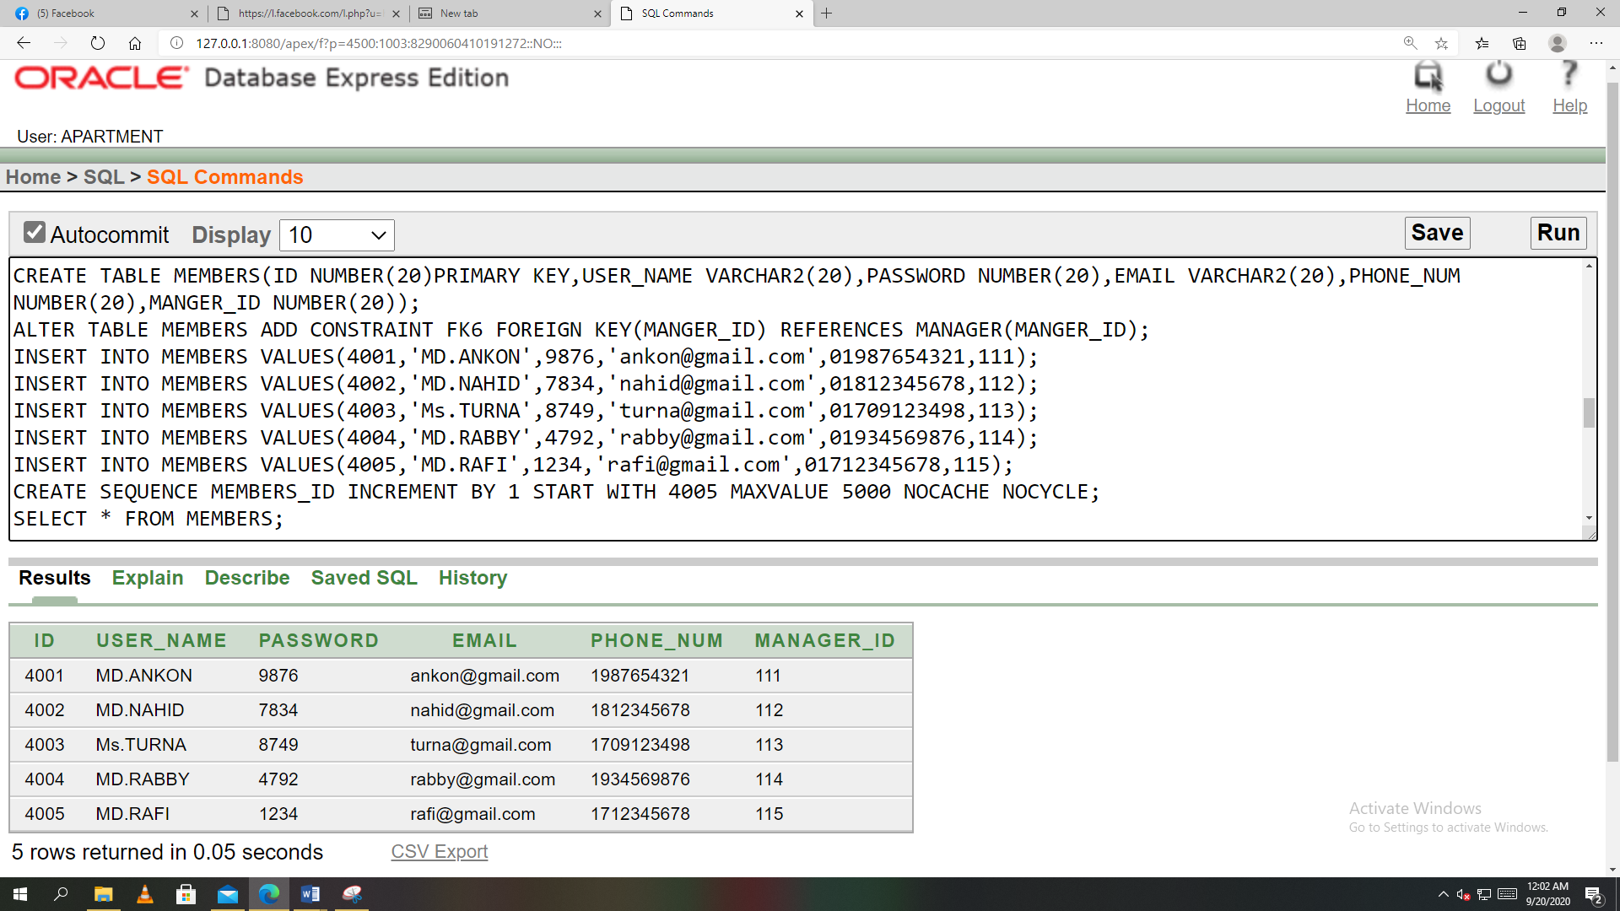

Table FOREIGN_KEY:

CREATE TABLE FOREIGN_KEY(APT_ID NUMBER(20),ID NUMBER(20));

ALTER TABLE FOREIGN_KEY ADD CONSTRAINT FK7 FOREIGN KEY(APT_ID) REFERENCES APARTMENT(APT_ID);

ALTER TABLE FOREIGN_KEY ADD CONSTRAINT FK8 FOREIGN KEY(ID) REFERENCES MEMBERS(ID);

INSERT INTO FOREIGN_KEY VALUES (1001,4001);

INSERT INTO FOREIGN_KEY VALUES (1002,4002);

INSERT INTO FOREIGN_KEY VALUES (1003,4003);

INSERT INTO FOREIGN_KEY VALUES (1004,4004);

INSERT INTO FOREIGN_KEY VALUES (1005,4005);

SELECT * FROM FOREIGN_KEY;

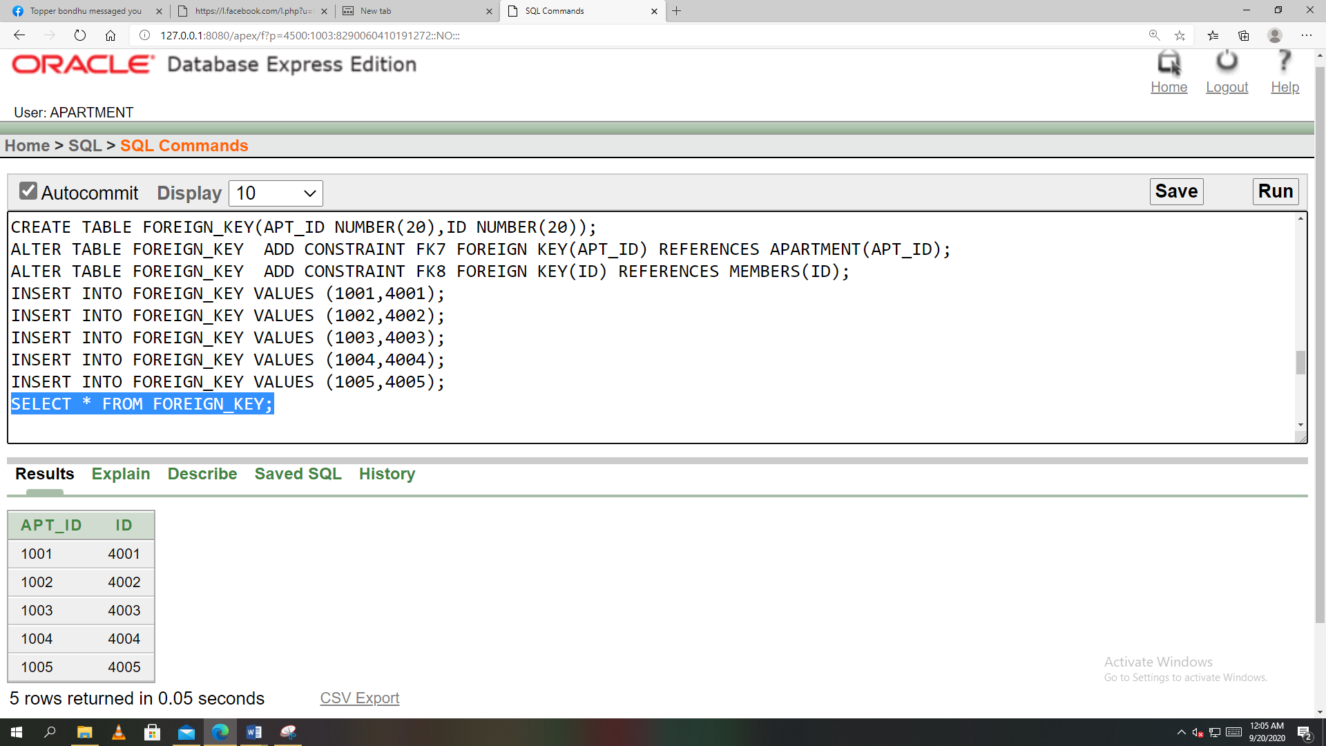

Table RENT:

CREATE TABLE RENT(RENT_ID NUMBER(20)PRIMARY KEY,LATE_FEE NUMBER(20),RENT_FEE NUMBER(20),AP_FACILITY_FEE NUMBER(20),PAYMENT_DATE DATE,PAYMENT_AMOUNT NUMBER(20),DUE_DATE DATE);

INSERT INTO RENT VALUES (5001,200,37000,3000,TO_DATE('5-1-2020','dd-mm-yyyy'),40000,TO_DATE('10-1-2020','dd-mm-yyyy'));

INSERT INTO RENT VALUES (5002,200,45000,5000,TO_DATE('1-1-2020','DD-MM-YYYY'),50000,TO_DATE('10-1-2020','DD-MM-YYYY'));

INSERT INTO RENT VALUES (5003,200,31000,4000,TO_DATE('4-1-2020','DD-MM-YYYY'),35000,TO_DATE('15-1-2020','DD-MM-YYYY'));

INSERT INTO RENT VALUES (5004,200,33000,5000,TO_DATE('1-1-2020','DD-MM-YYYY'),38000,TO_DATE('10-1-2020','DD-MM-YYYY'));

INSERT INTO RENT VALUES (5005,200,50000,5000,TO_DATE('5-1-2020','DD-MM-YYYY'),55000,TO_DATE('14-1-2020','DD-MM-YYYY'));

CREATE SEQUENCE RENT_RENT_ID INCREMENT BY 1 START WITH 5005 MAXVALUE 6000 NOCACHE NOCYCLE;

SELECT * FROM RENT;

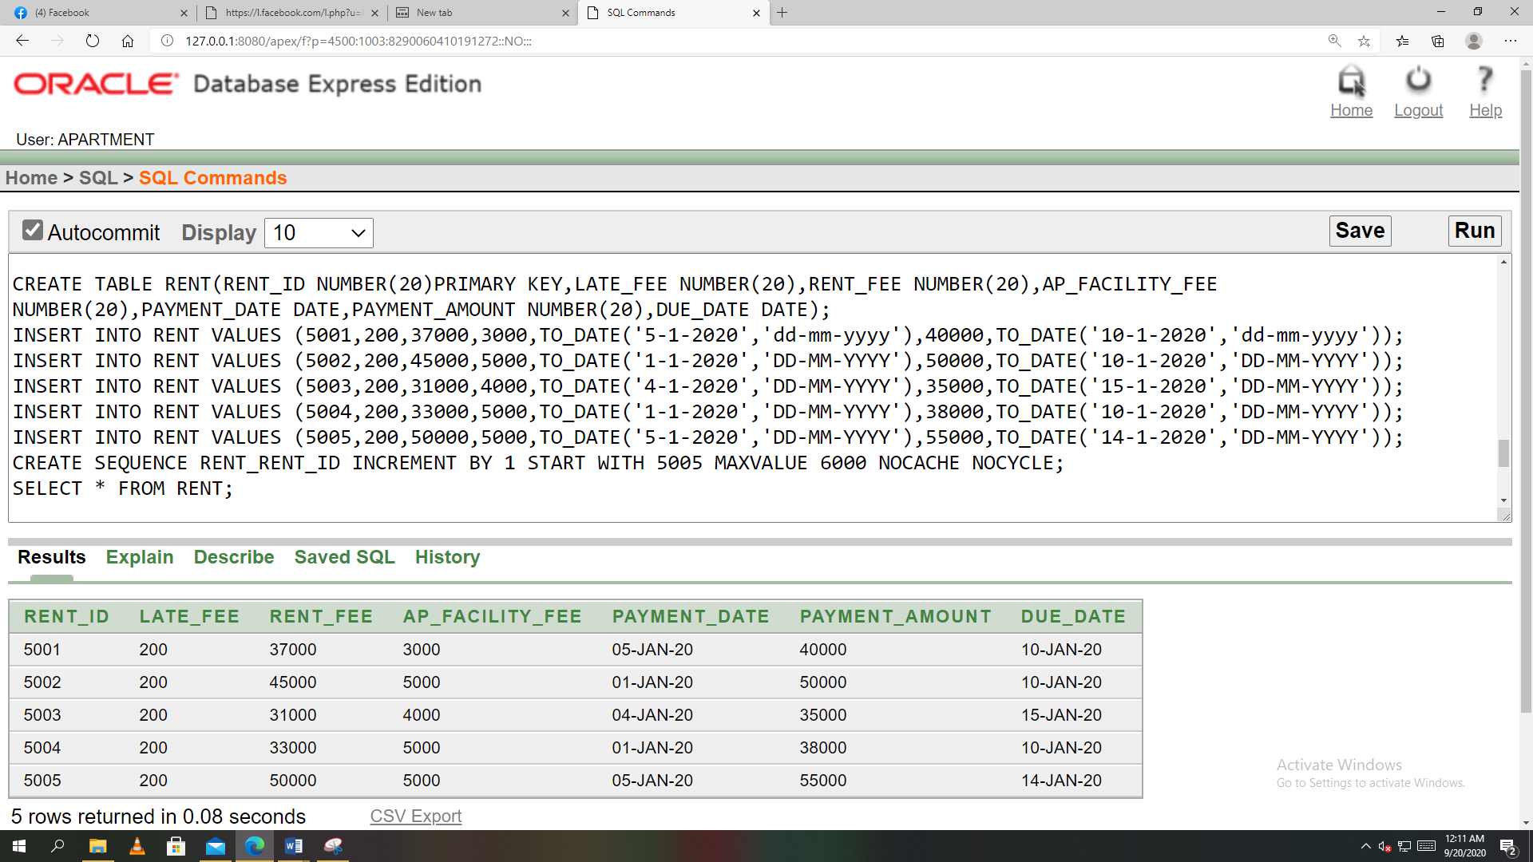

Table FOREIGN_KEY2:

CREATE TABLE FOREIGN_KEY2(ID NUMBER(20),RENT_ID NUMBER(20));

ALTER TABLE FOREIGN_KEY2 ADD CONSTRAINT FK9 FOREIGN KEY(ID) REFERENCES MEMBERS(ID);

ALTER TABLE FOREIGN_KEY2 ADD CONSTRAINT FK10 FOREIGN KEY(RENT_ID) REFERENCES RENT(RENT_ID);

INSERT INTO FOREIGN_KEY2 VALUES(4001,5001);

INSERT INTO FOREIGN_KEY2 VALUES(4002,5002);

INSERT INTO FOREIGN_KEY2 VALUES(4003,5003);

INSERT INTO FOREIGN_KEY2 VALUES(4004,5004);

INSERT INTO FOREIGN_KEY2 VALUES(4005,5005);

SELECT * FROM FOREIGN_KEY2 ;

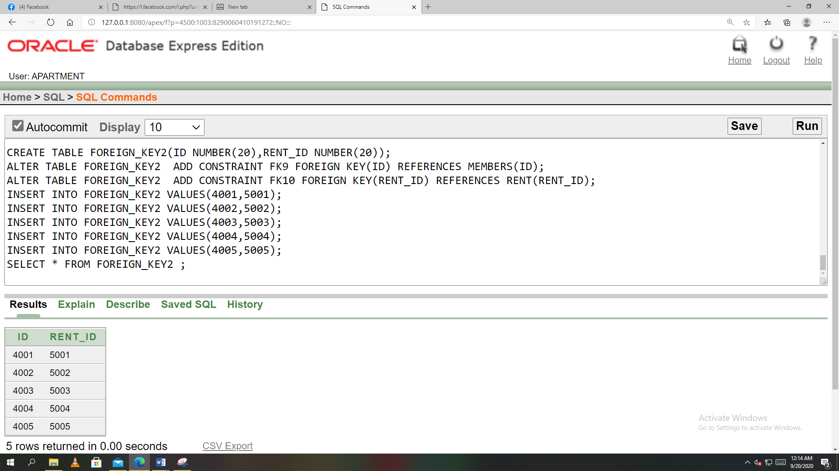

**Query Writing:**

**SUB-QUERY:**

**1. Display the manager name who earns more than MD. Niloy.**

* SELECT MANAGER_NAME AS M_NAME FROM MANAGER WHERE M_SALARY>(SELECT M_SALARY FROM MANAGER WHERE MANAGER_NAME='MD.NILOY');

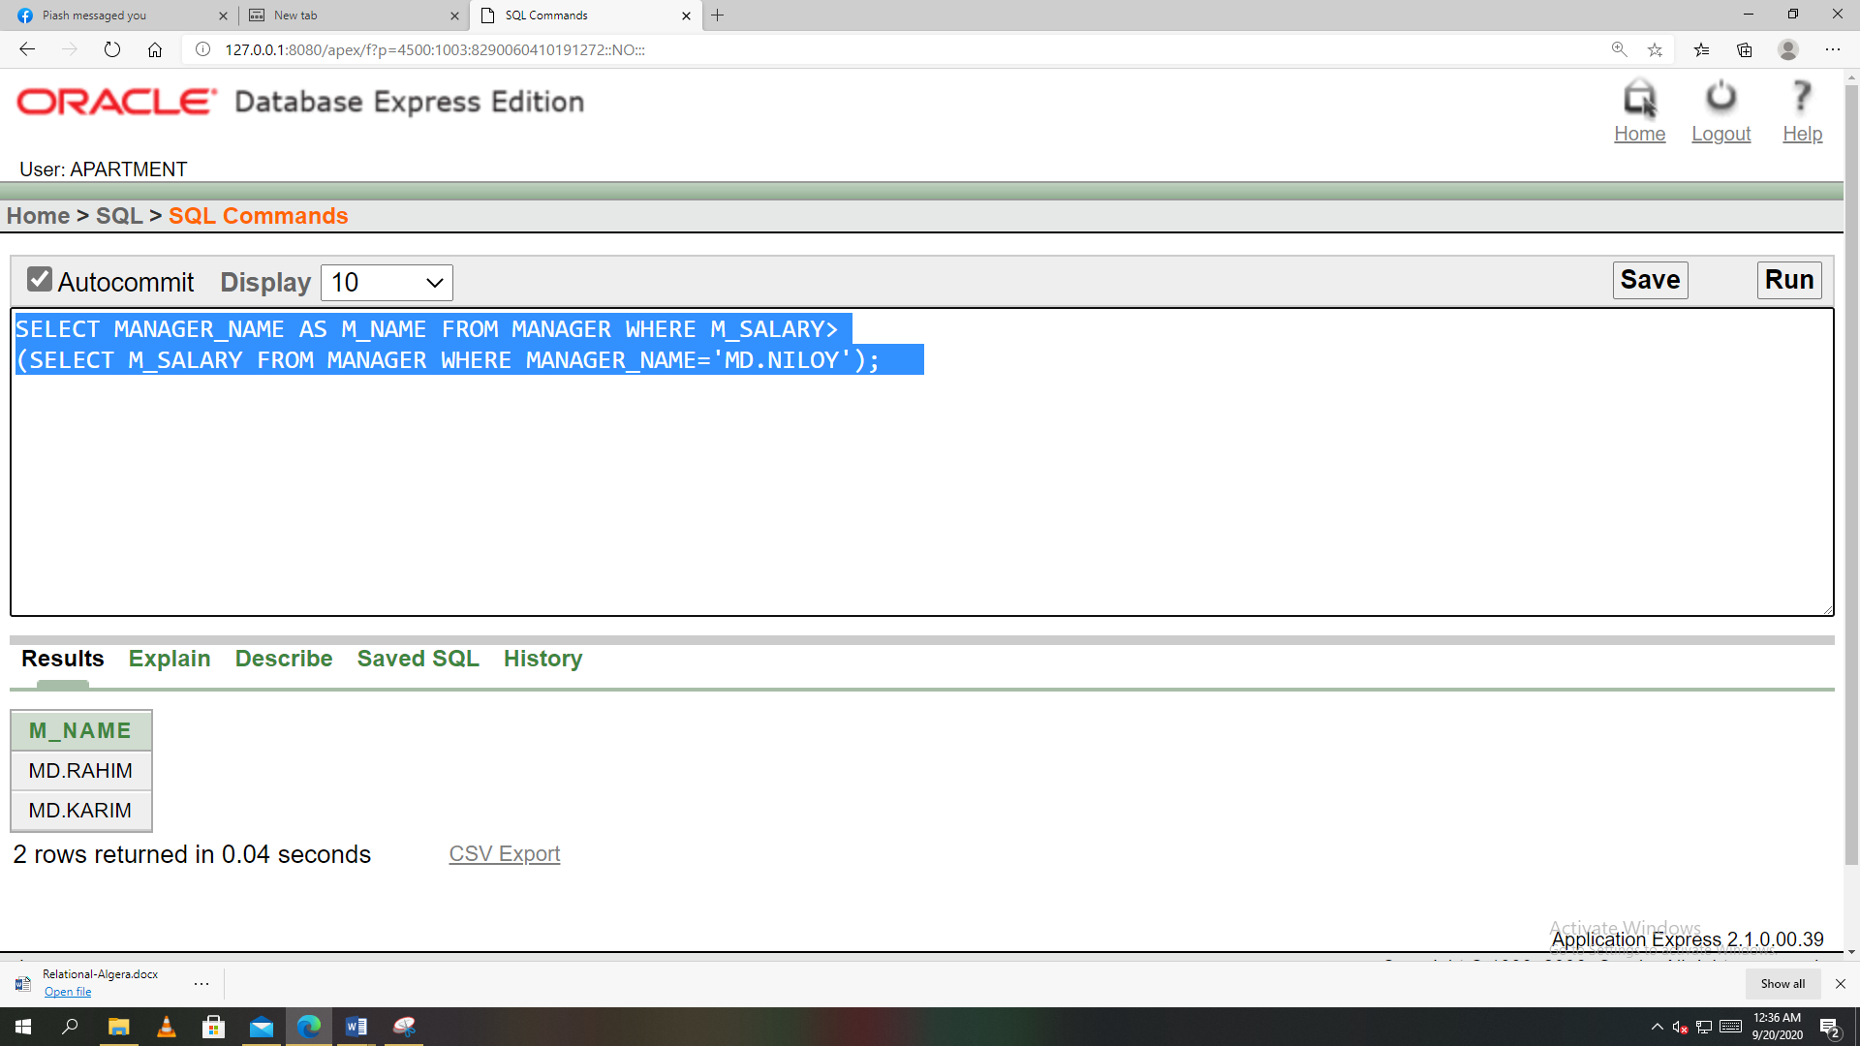

**2. Display the manager name who joined after MD. Karim.**

* SELECT MANAGER_NAME AS M_NAME FROM MANAGER WHERE BUILDING_ID>(SELECT BUILDING_ID FROM MANAGER WHERE MANAGER_NAME='MD.KARIM');

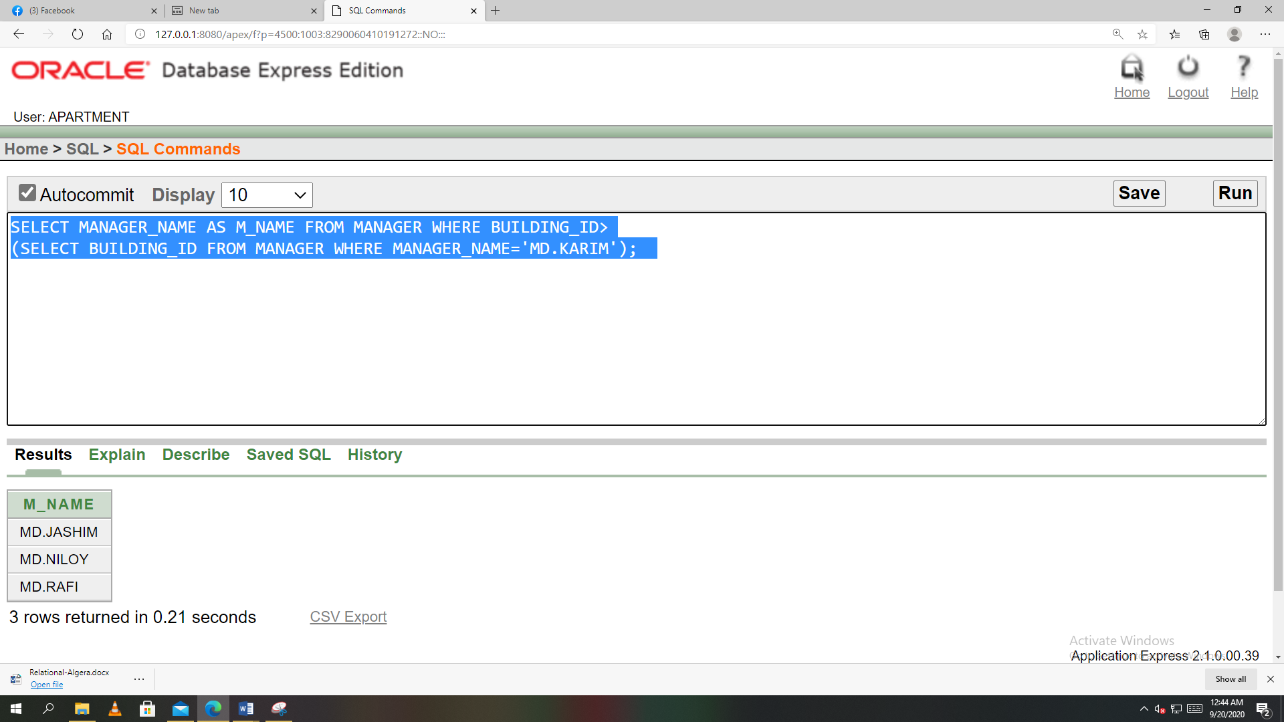

**JOINING:**

**1. Write a query to display building_short_name, building_full_name, water, gas from the table apartment_building and apartment_facilities?**

* SELECT APARTMENT_BUILDING.BUILDING_SHORT_NAME,APARTMENT.BEDROOM_COUNT FROM APARTMENT_BUILDING,APARTMENT WHERE APARTMENT_BUILDING.BUILDING_ID=APARTMENT.BUILDING_ID;

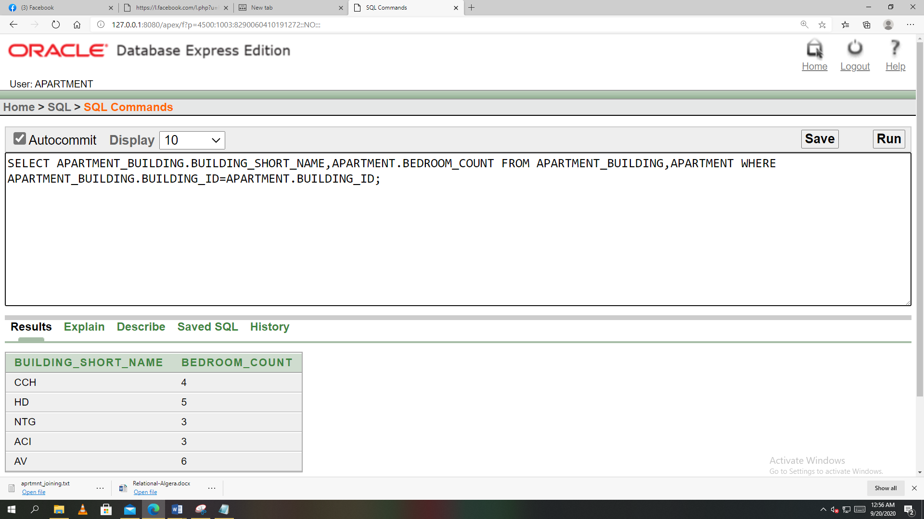

**2. Write a query to display building short name, building full name, water, gas from the table apartment building and apartment facilities ?**

* SELECT APARTMENT_BUILDING.BUILDING_SHORT_NAME,APARTMENT_BUILDING.BUILDING_FULL_NAME,APARTMENT_FACILITIES.WATER,APARTMENT_FACILITIES.GAS FROM APARTMENT_BUILDING,APARTMENT_FACILITIES WHERE APARTMENT_BUILDING.BUILDING_ID=APARTMENT_FACILITIES.BUILDING_ID;

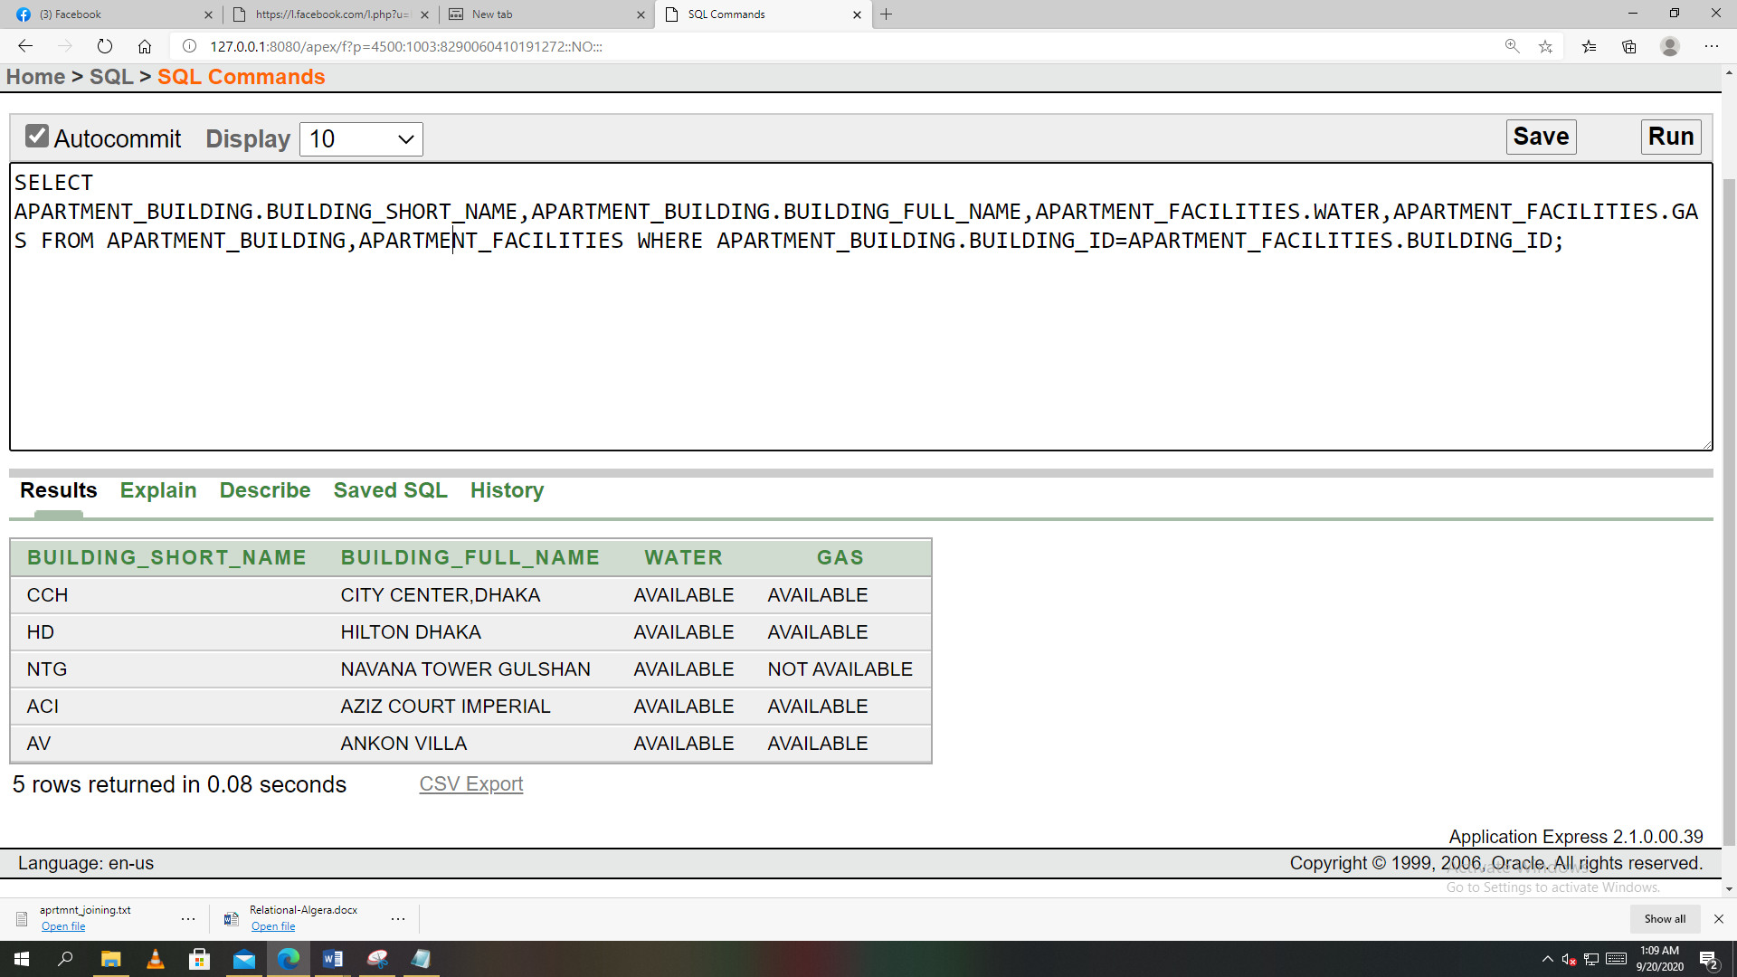

**VIEW:**

**1.Create a view called RENTVIEW based on the RENT_ID,RENT_FEE and PAYMENT_AMOUNT from the RENT table.**

* CREATE TABLE RENT(RENT_ID NUMBER(20)PRIMARY KEY,LATE_FEE NUMBER(20),RENT_FEE NUMBER(20),AP_FACILITY_FEE NUMBER(20),PAYMENT_DATE DATE,PAYMENT_AMOUNT NUMBER(20),DUE_DATE DATE);

INSERT INTO RENT VALUES (5001,200,37000,3000,TO_DATE('5-1-2020','dd-mm-yyyy'),40000,TO_DATE('10-1-2020','dd-mm-yyyy'));

INSERT INTO RENT VALUES (5002,200,45000,5000,TO_DATE('1-1-2020','DD-MM-YYYY'),50000,TO_DATE('10-1-2020','DD-MM-YYYY'));

INSERT INTO RENT VALUES (5003,200,31000,4000,TO_DATE('4-1-2020','DD-MM-YYYY'),35000,TO_DATE('15-1-2020','DD-MM-YYYY'));

INSERT INTO RENT VALUES (5004,200,33000,5000,TO_DATE('1-1-2020','DD-MM-YYYY'),38000,TO_DATE('10-1-2020','DD-MM-YYYY'));

Create view RENTVIEW as select RENT_ID,RENT_FEE,PAYMENT_AMOUNT from RENT;

select * from RENTVIEW**;**

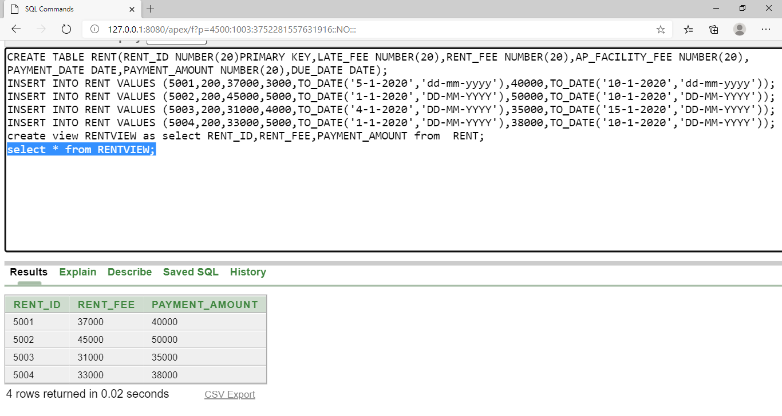

**2. Create a view called APARTMENTVIEW based on the APT_ID,BATHROOM_COUNT,BEDROOM_COUNT and RENTAL_PRICE from the APARTMENT table.**

* CREATE TABLE APARTMENT(APT_ID NUMBER(20)PRIMARY KEY,BATHROOM_COUNT NUMBER(20),BEDROOM_COUNT NUMBER(20),RENTAL_PRICE NUMBER(30));

INSERT INTO APARTMENT VALUES (1001,3,4,40000);

INSERT INTO APARTMENT VALUES (1002,4,5,50000);

INSERT INTO APARTMENT VALUES (1003,2,3,35000);

INSERT INTO APARTMENT VALUES (1004,3,3,38000);

Create view APARTMENTVIEW as select APT_ID,BATHROOM_COUNT,BEDROOM_COUNT,RENTAL_PRICE from APARTMENT ;

Select * from APARTMENTVIEW;

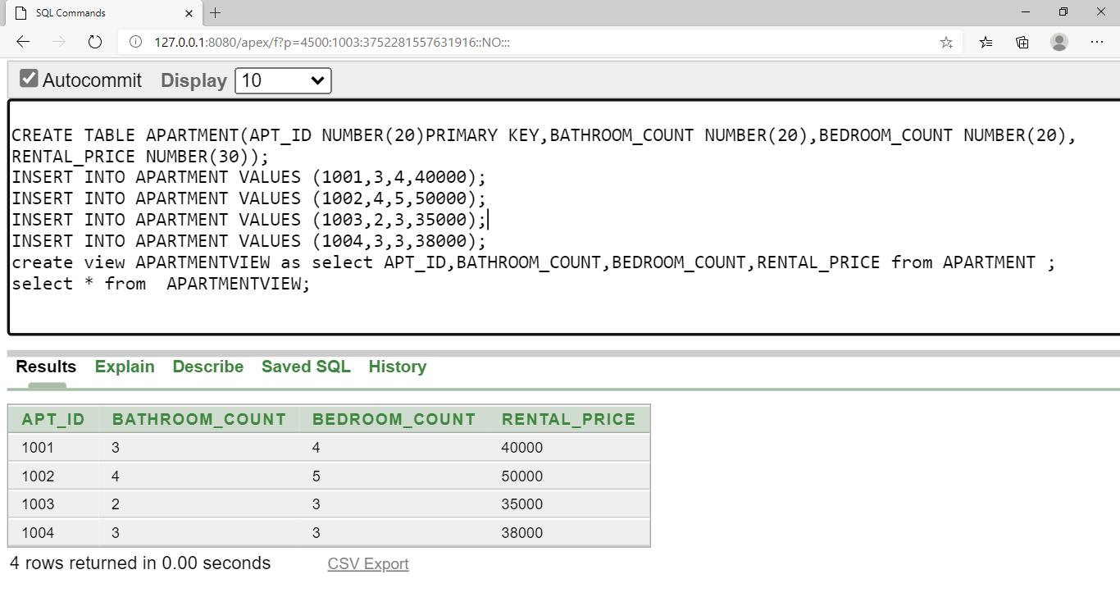

**Relational Algebra:**

* + - 1. **Find the manager_name where m_salary is greater than 25000.**
* π manager_name(σ m_salary>25000(manager)) {Table: MANAGER}
  + - 1. **Find the user_name and email where manager _id is 112.**
* π user_name,email(σ manager_id =”112”(Member)) {Table: MEMBER}
  + - 1. **Find the apt_id where rental_price is greater than 38000.**
* π Apt_id(σ rental_price>38000(Apertment)) {Table: APARTMENT_TABLE}

1. **Find the F_id where building_id is 103.**

* π F_id(σ building_id=’103’(Apartment_facilities)) {Table: APARTMENT_FACILITIES }

1. **Find the rent_id where payment_amount is 35000.**

* π rent_id(σ payment_amount=”35000”(Rent)) {Table: RENT}

**Conclusion:**

This project is relatively simple to understand and implement. It fulfills all the current requirements of local building management company. The system is very user-friendly; a person with basic computer skills can easily use this system.

Queries of this project **“Apartment Management System”** are run in 'Oracle 10g'.Here we made 6 relationship among all the entities with cardinality.

In our project, we have mentioned the queries as well as inserted screenshots of the tables we created using those queries. Normalization process makes this project simpler.

**This project overall covers the following fields:**

* + - 1. **Apartment details:** This AMS stores all the information, records and data related to apartment. These data include total number of flats and rooms, types of rooms.
      2. **Personal Information:** Personal information of every manager & member is also stored in this system.
      3. **Facilities Provided:** Whether an apartment provides facilities ( water, gas, electricity, security ) or not is also mentioned in this system.
      4. **Rent Collection:** This system also gives solution to rent collection issues.

**Difficulties & Problems**

* **Leak of personal information:** Personal information of manager and members may leak when someone search for an available apartment.

* **Less Security:**  Due to lack of proper security this system can be easily hacked.
* **Parking Slot Confusion:** This system doesn’t give any solution to mark parking slot for each member individually.

**Future Development:**

Adding more security to this system will solve the possibility of information leakage and hacking.

If parking slots are given unique id for per apartment, that will solve the parking slot confusion.

Including GPS tracking in this system will give the system a smart touch. People will be able to find out vacant apartment building through online searching.

Moreover, for one or more apartments in a building, the database has to collect a large amount of data, which makes the system very expensive to upgrade and store data. In future, we will try to make it more convenient to reduce the costing.

If these issues are addressed, it is expected that in Future this system will be more convenient and user friendly.

Lastly, new features can be added into the system as per user requirement. The project is very flexible in that aspect.